Now Featuring
- Software download from website
- Simplified installation
VersaIMAGE-GOLD

Installation Guide

October 2007 Edition 1.2
VersaIMAGE Software Corporation
7600 Grand River Rd.
Suite 230
Brighton, MI 48114
Sales & Support: (810) 225-9720
Toll Free: (866) 208-8474
Fax: (810) 225-9726
www.versasoftware.com

sales@versasoftware.com

support@versasoftware.com

Contact VersaIMAGE Sales for current available authorized license options.

Click OK to close the VersaImage Licensing Information window.

Page 2 support @versasoftware.com
VersaIMAGE Software Page 23

General information 3
Before Getting Started 3
Downloading the Software 4
Software Installation 7
Single-User Type 8
Network Workstation Type 11
Network Server Type 15
Installation Complete 19
Software License Installation 20
Viewing License Information 22

Table of Contents

GENERAL INFORMATION

VersaIMAGE-GOLD is easy to use, Microsoft Windows-based, document scanning, image management, retrieval and distribution software. The software uses the Twain scanner interface for color, gray scale and B&W paper scanning. VersaIMAGE-GOLD uses Microsoft "Access" or "SQL Server" databases and its database search arguments may be coupled with OCR "full text search" requests to provide quick retrieval of individual documents within file folders.

Sample screenshots used in this guide feature Microsoft’s Internet Explorer and Download Manager, running under the Windows XP operating system. Actual displays may vary depending upon the internet browser installed at your site.

It is strongly recommended that you exit all Windows applications before running the software installation process.

Please note: VersaIMAGE Software Corporation does not furnish or bundle Microsoft software components which support the VersaIMAGE-GOLD application, such as database, email, and operating system functionality. Customers must purchase Microsoft components themselves.

BEFORE GETTING STARTED
When installing the application in a networked environment, perform the network server installation before installing the workstations.

For network server installations, log into the server as Administrator. This is very important, as the install process will be installing a network service. Also, create a shared folder on the drive that the application will be hosted from. We suggest calling it VersaShare. Now, download the software and begin the server installation process.

For network workstation installations, log into the workstation as Administrator. Map a network drive to the Versa share point (the VersaShare folder on the server). Note: Do NOT map directly to the VersaIMG subfolder. Next, from the mapped drive, open the VersaIMG subfolder and run the setvinet.exe application. Now, continue with the workstation installation process.
A confirmation message is displayed when the Site Key is accepted.

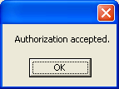

VIEWING LICENSE INFORMATION
License details can be reviewed while you are using the application. If Security Levels are enabled for your site, then you must have Administrator (Level 5) access. Also, all databases must be closed (Click File then Close Database). Click File then Maintenance then Licensing Info. The VersaImage Licensing Information window will display.

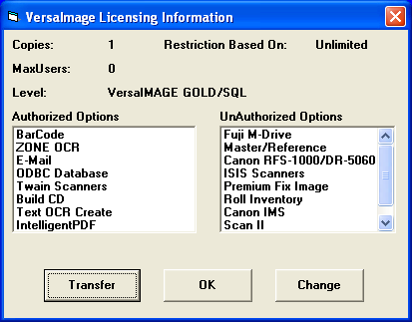
Page 22 Support : (810) 225-9720
VersaIMAGE Software Page 3

DOWNLOADING THE SOFTWARE

Download the VersaIMAGE-GOLD/SQL application from:

http://www.versasoftware.com/files/gold/versaimg.exe

You can choose to Run the installation over the internet, or Save the installation application to your local storage first, then launching the install process from this local file.

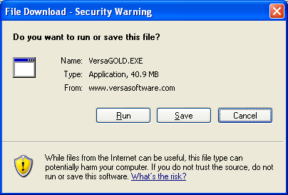

Page 4 support @versasoftware.com
VersaIMAGE Software Page 21
The VersaImage Licensing window will display.

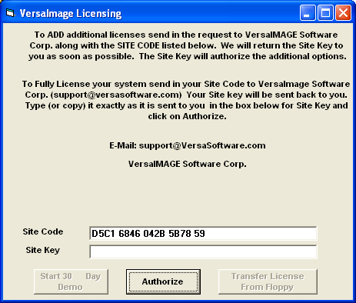

Site Code values are unique to each installation, and can not be transferred to another machine.

To receive the Site Key to activate the license, email your unique Site Code value to:
support@versasoftware.com

The corresponding Site Key value will be returned. Enter this value, in UPPER case, into the Site Key field, then click Authorize.

If you click Run, the installation application will first download into a local temporary folder.

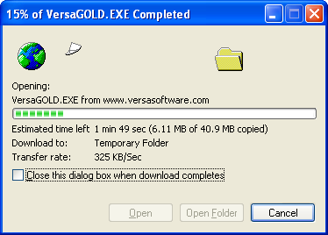

If you click Save, the installation application will first download into the local folder of your choice. Specify the folder in the Save in: field, then click the Save button.

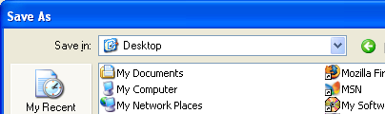

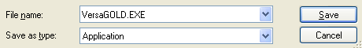

SOFTWARE LICENSE INSTALLATION

Now that the application software has successfully been installed, the software license needs to be installed.

Locate and double-click on the new desktop VersaIMAGE-GOLD icon.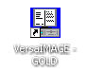 The VersaImage Demo window will display.

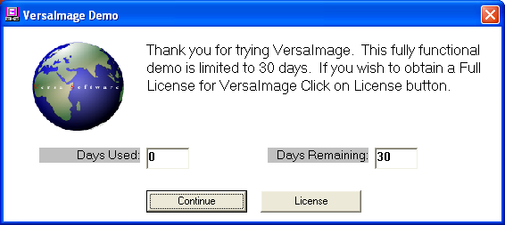

Click the License button.
Page 20 Support : (810) 225-9720
VersaIMAGE Software Page 5

INSTALLATION COMPLETE

When the System Configuration update has completed, the Installation Complete window will display. Click Finish to successfully complete the software installation process.

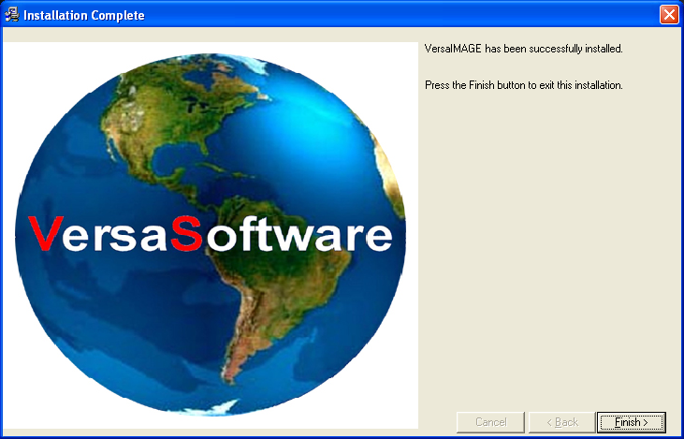

The download will start. When the download completes, click Run to start the installation process.

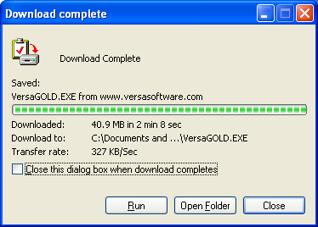

Whether you clicked Run or Save, when the download completes a Security Warning may display. This is OK. Click Run and the installation process will start.

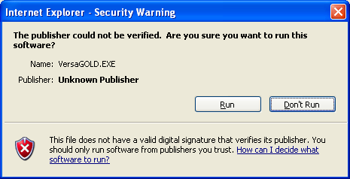

Page 6 support @versasoftware.com
VersaIMAGE Software Page 19

SOFTWARE INSTALLATION

The software installation process begins by displaying the Customer License Agreement window.

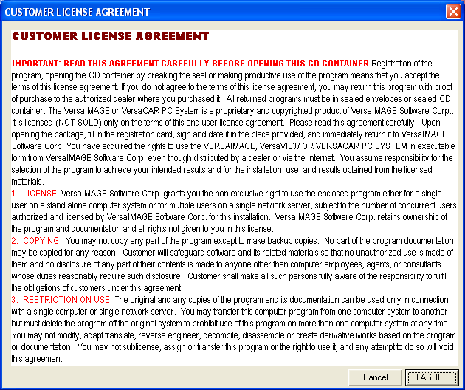

Please read and understand the terms and conditions of this Agreement before continuing. Click I AGREE to continue with the software installation process under the terms of this Agreement.

Or, click Cancel to terminate the installation process.

The software will be installed into the specified destination folder. Installation progress is displayed onscreen.

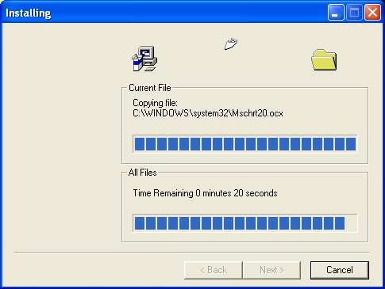

After the files have successfully been copied onto the workstation, the Windows System Configuration is updated with the new application information.

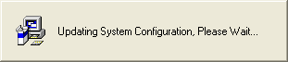

This completes the Network Server installation process.
The Installation Complete window will display.

Page 18 Support : (810) 225-9720
VersaIMAGE Software Page 7

The Backup Replaced Files window will display.

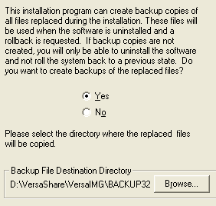

If Yes is selected, by default, a sub-folder named BACKUP32 will automatically be created. Or, if required, consult your local System Administrator for the Backup File Destination Directory information.

Click Next to continue the installation process.

SELECT INSTALLATION TYPE

Select the Installation Type, then click Next.

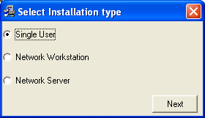

SINGLE USER INSTALLATION

This option installs and configures the software to run on a stand-alone PC.

The Welcome window will display, click Next to continue.

The Get Registration Information window will display. Enter the Name and Company of the registered owner of the software.

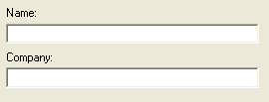

When completed, click Next to continue the installation process.

Note: If an existing version of the software is detected, a notice is displayed. Click Next to continue the installation process.

Page 8 support @versasoftware.com
VersaIMAGE Software Page 17

The Choose Destination Location window will display. Specify the folder where the application database and/or CAR files will be stored. By default, and recommended, the c:\VersaIMG folder is specified.

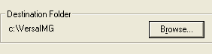

However, if required, click Browse to specify a different folder.

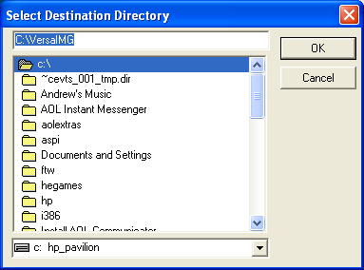

Select the appropriate Drive letter and folder name. Click OK to return to the Choose Destination Location window.

Click Next to continue the installation process.

Page 16 Support : (810) 225-9720
VersaIMAGE Software Page 9
The Choose Destination Location window will display. Here we specify the folder where the application database and/or CAR files will be stored.

Click Browse to locate the VersaShare folder that was created in the Before Getting Started section.

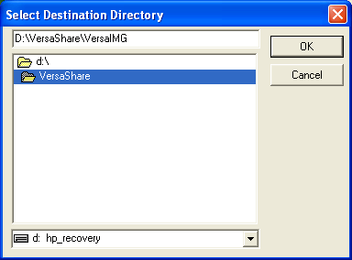

Select the appropriate server Drive letter and the VersaShare folder name. Then, append (enter) the \VersaIMG sub-folder name onto the destination path. See example above.

Click OK to return to the Choose Destination Location window. The Destination Folder, with a possible different server drive letter, should be similar to…

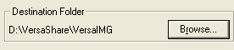

Click Next to continue the installation process.

NETWORK SERVER INSTALLATION

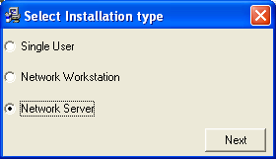

This option installs and configures the software to run on a network server.

The Welcome window will display, click Next to continue.

The Display Registration Information window will display. Verify that the Name and Company information displayed is the registered owner of the software.

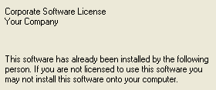

When completed, click Next to continue the installation process.

The software will be installed into the specified destination folder. Installation progress is displayed onscreen.

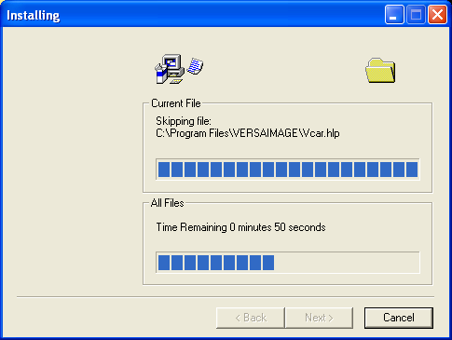

After the files have successfully been copied onto the PC, the Windows System Configuration is updated with the new application information.

This completes the Single User installation process.
The Installation Complete window will display.

Page 10 support @versasoftware.com
VersaIMAGE Software Page 15

NETWORK WORKSTATION INSTALLATION

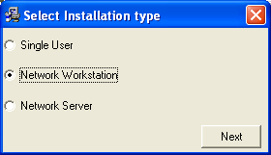

This option installs and configures the software to run on a networked PC workstation.

The Welcome window will display, click Next to continue.

The Display Registration Information window will display. Verify that the Name and Company information displayed is the registered owner of the software.

When completed, click Next to continue the installation process.

The software will be installed into the specified destination folder. Installation progress is displayed onscreen.

After the files have successfully been copied onto the workstation, the Windows System Configuration is updated with the new application information.

This completes the Network Workstation installation process.
The Installation Complete window will display.

Page 14 Support : (810) 225-9720
VersaIMAGE Software Page 11

The Backup Replaced Files window will display.

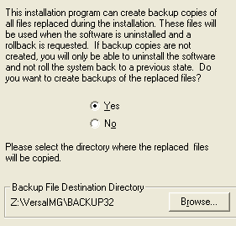

If Yes is selected, by default, a sub-folder named BACKUP32 will automatically be created. Or, if required, consult your local System Administrator for the Backup File Destination Directory information.

Click Next to continue the installation process.

The Choose Destination Location window will display. Here we specify the folder where the application database and/or CAR files will be stored.

Click Browse to locate the mapped drive to the VersaShare server folder that was created in the Before Getting Started section. In this example, the mapped drive is Z:.

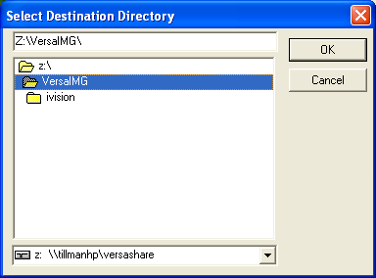

Select the mapped drive for the VersaShare server folder in the drop-down box. Then, select the \VersaIMG sub-folder to complete the destination path. See example above.

Click OK to return to the Choose Destination Location window. The Destination Folder, with a possible different mapped drive letter, should be similar to…

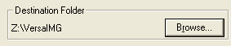

Click Next to continue the installation process.

Page 12 support @versasoftware.com
VersaIMAGE Software Page 13

