

VersaIMAGE- Gold

Quick Guide

Now Featuring
- Auto-Indexing from Barcodes and OCR Zones
- OCR text searches of scanned images
- Intelligent PDF processing
- HIPPA-compliant tracking feature

October 2007 Edition 1.8
VersaIMAGE Software Corporation
7600 Grand River Rd.
Suite 230
Brighton, MI 48114
Sales & Support: (810) 225-9720
Toll Free: (866) 208-8474
Fax: (810) 225-9726
www.versasoftware.com

sales@versasoftware.com

support@versasoftware.com

General information 3
1.0.0 Application Setup Preferences
Set a Default Database 4
Scanner Setup 6
Indexing Setup 8
Imaging Options 10
Search Results Sort Sequence 12
Printer Setup 13
Email Setup 14
Fax Setup 16
OCR Processing Setup 17
Image Display Modes 19
Image Viewing Features 20
2.0.0 Perform Data Searches
Index Text Searches 21
OCR Bookmark Searches 23
3.0.0 Printing & Faxing images 25
4.0.0 Scanning images
Image Correction 24
Make Folder and Scan (F2/F5) 28
Batch Scanning (F5) 29
5.0.0 Importing information 32
6.0.0 Exporting information
Distribution Folders 34
7.0.0 Indexing functions
Zoom Zones 42
Auto-Index OCR and Barcode Zones 43
Split Batches into Folders 47
8.0.0 Image QC functions
Rescan an Image 48
Global Changes to Index Information 49
Deleting Images 50
9.0.0 PDF Processing of Images 51
10.0.0 Creating CDs 52
11.0.0 Create a new Client Application 53
12.0.0 Security, Defaults, & Maintenance
Enable Security 55
Software License Information 56
13.0.0 HIPAA tracking and reporting 58

Table of Contents
Take some notes…
Page 2 support @versasoftware.com
VersaIMAGE Software Page 59

GENERAL INFORMATION ABOUT THIS GUIDE:
This Quick Guide uses an internally stored database named Shore Mortgage for all examples. The Guide is organized by subject and feature capabilities. The logical subjects are grouped together and indexed appropriately. By following the exact steps outlined in this Guide, you will be able to demonstrate most features of VersaIMAGE- Gold quickly without the need to study the software functions in greater detail.

CAPABILITIES OF VERSAIMAGE-GOLD INCLUDE:
- OCR feature automatically converts text (not handwriting) on each scanned image to searchable text.
- The text can be extracted from Gold to other applications.
- Scanning is done in TWAIN and may include color or grayscale.
- Standard PDF conversion of images is available.
- Intelligent (text searchable) PDF file output to CD is an optional feature.
- Microfilm features/control is not included, requires VersaIMAGE 32

COMPUTER REQUIREMENTS AND SETTINGS:
Intel Pentium 4 or AMD Athlon 64 processor, 1 GHz or faster
Microsoft Windows 2000 or XP Pro
256MB RAM (1GB RAM or higher recommended)
20GB + of Fixed Disk Space.
Allow at least 500MB for TEMP FILE space.
Note: VersaIMAGE-Gold deletes these files automatically

FUNCTION KEY INDEX:
* F-2 SCAN AND INDEX FOLDER
* F-3 SCAN AND INSERT
* F-4 SHOW SCANNER SETTINGS
* F-5 COMPLETE F2 SCAN PROCESS / SCAN BATCH
* F-6 RE-SCAN SINGLE IMAGE
* F-10 DE-SKEW IMAGE (when image is enlarged)
* F-11 ROTATE IMAGE (when image is enlarged)
* F-12 SPLIT FOLDER

13.0.0 HIPPA-COMPLIANT TRACKING AND REPORTING FEATURE

A HIPPA-compliant tracking and reporting feature can be enabled by the System Administrator. To enable tracking for a database, click the File / Preferences / Use Hippa Logging option so that a checkmark is displayed.

Reviewing and reporting on the tracking information can be accessed with the File / Maintenance / View Hippa Logs option. Again, this option is available only to the System Administrator (or Level 5 security users), and after all databases have been closed.

  - VIEWING THE HIPPA LOG INFORMATION

When the View Hippa Logs option is accessed an empty screen is displayed. Specify search criteria in the fields near the bottom of the screen. By default, search criteria to select the last six months of information are pre-specified, but feel free to change the search criteria to meet your specific requirements.

Click the Search button and the log entries corresponding to the specified search criteria are displayed.

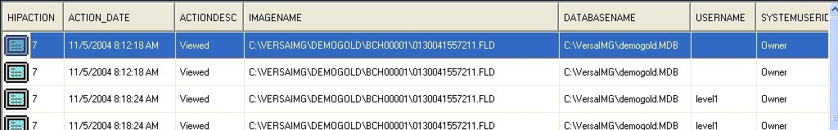

The information listed can also be prepared into a print-ready Adobe PDF format document by clicking the Print button.

To close this window and return to the application, click the Red-X in the upper-right corner of the screen.

Page 58 Support : (810) 225-9720
VersaIMAGE Software Page 3

To upgrade your software license, click Change. The VersaIMAGE Licensing window will display.

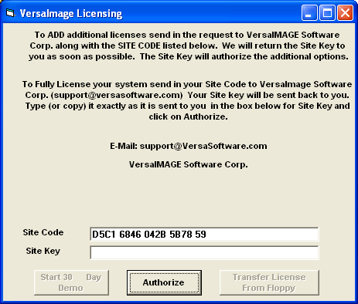

Site Code values are unique to each installation, and can not be transferred to another machine.

To receive the Site Key to activate the license, email your unique Site Code value, Name, Company Name, and Dealer Name if known to:
support@versasoftware.com

The corresponding Site Key value will be returned. Enter this value, in UPPER case, into the Site Key field, then click Authorize.

A confirmation message is displayed when the Site Key is accepted.

  - VERSAIMAGE-GOLD DEMO GUIDE:

Verify that the document scanner is connected and powered on.
Double Click on the VersaIMAGE-Gold desktop icon to start the application. The application will startup without a database specified.

SELECTING THE DEMONSTRATION DATABASE
For this guide, the provided demonstration database file "Shore Mortgage.CAR" will be used. To open the database…
Click on File then on Open Database.
Choose the Shore Mortgage.CAR file and click on Open.

SPECIFY APPLICATION SETUP PREFERENCES

1.1.0 How to SET a DEFAULT DATABASE
To specify the database that will automatically be opened at application startup, click on File then Preferences and Defaults.

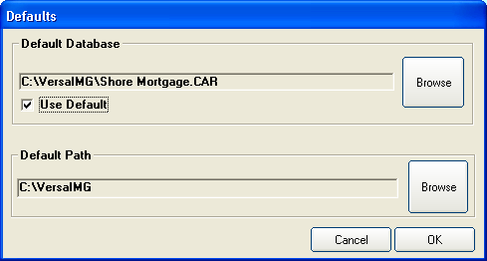

1.1.1 HOW TO SET A DEFAULT PATH TO THE CORRECT DIRECTORY
In the Default Path box, click the Browse  button.

Page 4 support @versasoftware.com
VersaIMAGE Software Page 57

The Set System Default Path window will be displayed.
For networked installations, please consult with your local System Administrator.
For single user installations, click the down-arrow for Drives and select the correct drive letter. For most installs this will be the C: drive. Next, in the Directories field, double-click to select the correct directory. For most installs this will be the VersaIMG directory.

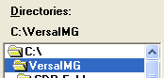

Click OK and Yes to confirm "This will change the Default Path..."

1.1.2 SPECIFY THE DEFAULT DATABASE
In the Default Database box, click the Browse button.
In the Default Database window, click on the database (.CAR file) to automatically be opened at system start-up, then click Open.
Verify the Use Default checkbox is checked. If it is not, click on the checkbox to set.

Click OK to save these settings.

12.2.0 HOW TO COMPACT A DATABASE
Click on File then Maintenance then Compact Database.
Enter Compact Code which is "today's" current date in YYMMDD form and/or email for Support.
Select (Click) on a Database (like NewApp.CAR) then click Open.
Click OK to the notification "VersaIMAGE is ready to compact ..."
Click OK to the “Compacting is Finished” notification.

12.3.0 HOW TO REPAIR A CORRUPTED DATABASE
Click on File then Maintenance then Repair Database.
Enter Repair Code which is "today's" current date in YYMMDD form and/or email for Support.
Select (Click) on a Database (like NewApp.CAR) then click Open.
Click OK to the “Repair Completed” notification.

12.4.0 VIEWING LICENSE INFORMATION
License details can be reviewed while you are using the application. If Security Levels are enabled for your site, then you must have Administrator (Level 5) access. Also, all databases must be closed (Click File then Close Database). Click File then Maintenance then Licensing Info. The VersaImage Licensing Information window will display.

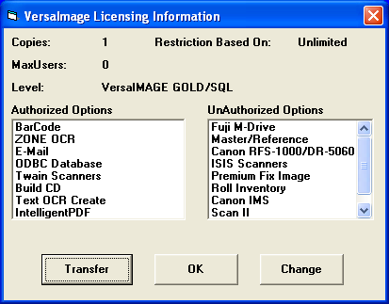
Page 56 Support : (810) 225-9720
VersaIMAGE Software Page 5

12.0.0 SECURITY, DEFAULTS AND MAINTENANCE FUNCTIONS

The database must be closed to enable or modify user security.

12.1.0 ENABLE AND MODIFY USER SECURITY
* Recommended: Setup the ADMIN user Id and password first!
* Keep a secure record of defined security User Names & Passwords.

Click on File then Close Database.
Click on File then Maintenance then Modify Security.
Click Use security located on the bottom left.
Note: Passwords ARE case-sensitive, User Names are not.

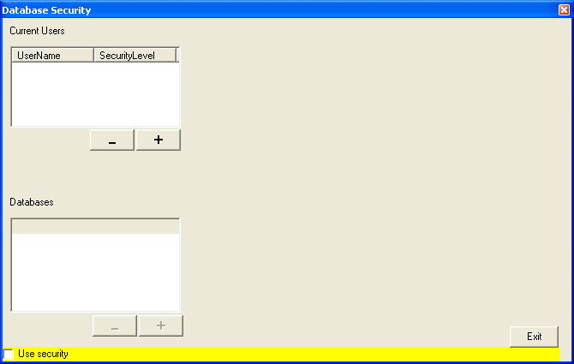

Click on + to create a new User Name and password.
Enter User Name, Password, and Security Level
Note: Admin users MUST have a Security Level of 5.
Click OK to save the user information.
Be sure to select the user and the press the + button located under databases to add which database(s) this user will have access to.

Click Exit to exit the Modify Security function.

1.2.0 SCANNER SELECTION
Allows the selection of the scanner interface drivers.

Click File, the select the Select Scanner option. Next, select the Twain scanner interface.

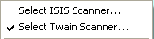

The Select Source window is displayed. Click on the appropriate scanner if more than one is listed, then click the Select button to complete the scanner selection process.

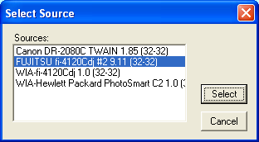

Note: For custom scanner interfaces, such as for Kodak IMS, i7300 and Fuji microfilm scanners, contact Technical Support for assistance

1.2.1 SCANNER SETUP
Before you scan, you will need to set the contrast, brightness, and other attributes on your paper scanner for the documents you will be scanning. You can do this through the Setup Scanner option.

Page 6 support @versasoftware.com
VersaIMAGE Software Page 55

1.2.1 SCANNER SETUP continued…

The Scanner Settings window will appear. If it doesn’t, either press F4 or choose Setup Scanner from the Scan Menu. The display will vary from scanner to scanner.

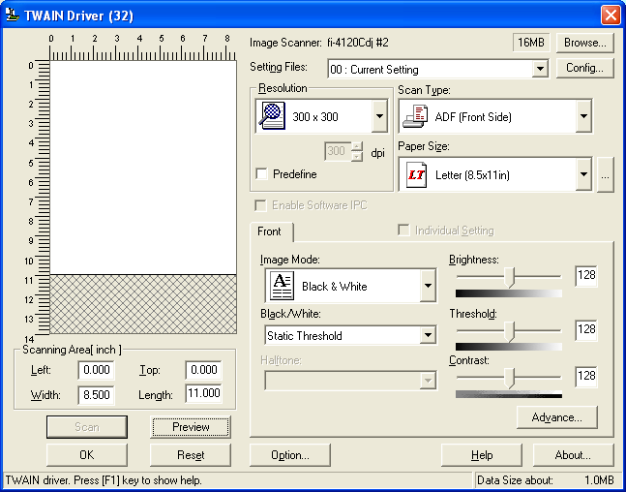
Set the parameters for your scanner in the window. For further information on how to set up your scanner, refer to your scanner manual.
When you finish, click the OK button to save these settings.
Note: You can adjust these settings later after you start your scanning operations, if necessary. To adjust your scanner settings later, click Scan, then select the Setup Scanner option. You can also simply press the F4 function key.

CREATE A NEW DATABASE continued…

Click on Add Field again.
Enter the third Field Name., for example Admit Date.
Click on the Field Type down-arrow and select Date.
Note that the Length and Field Format values are preset.
Press Tab to the Verification field.
No verification is required on this field, so (None) is fine.
Click the Fast Search checkbox for main search fields only. Otherwise, leave it blank.
Click OK to save this field definition.

Note: Did you make an error? You may click on the Modify Previous Field button to make corrections now.

The Add Field process can be repeated for additional field definitions. Up to 20 user-defined fields can be specified.

When the New Database set-up is complete, click OK to Create.
Two more fields are automatically appended; Image Address and OCR Search to complete the New Database specification.

Click on File and Open Database to begin using this new application. Your screen should look similar to the following…

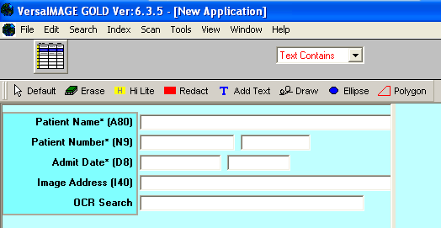

Page 54 Support : (810) 225-9720
VersaIMAGE Software Page 7

11.0.0 HOW TO CREATE A NEW DATABASE

Click on File and Close Database, to close the Shore Mortgage Demo database
Click on File and New Database.
On the New Database window, enter the new Database Name value of NewApp.
Click Save or press Enter on keyboard.
On the Create Master Table window, type in a desired (longer) Database Title, such as New Application.

Click on Add Field and the Add Field Definition window displays.
Enter the first Field Name, for example Patient Name.
Leave the Field Type as Alphanumeric.
Press Tab or click on Length and enter a field length of 80.
(Max 15 characters for Numeric fields, 80 for Alphanumeric fields).
Press Tab to the Verification field. The Field Format field was skipped because it is used for numeric fields only.
No verification is required on this field, so (None) is fine.
Click the Fast Search checkbox for main search fields only, the fields which will be used to do 90% of all searches. Otherwise, leave it blank.
Click OK to save this field definition.

Note: Did you make an error? You may click on the Modify Previous Field button to make corrections now.

Click on Add Field again.
Enter the second Field Name., for example Patient Number.
Click on the Field Type down-arrow and select Number, SSN.
Note that the Length and Field Format values are preset.
Press Tab to the Verification field.
Click on the down-arrow and select Dbl Key (Double Key) verification.
Click the Fast Search checkbox for main search fields only. Otherwise, leave it blank.
Click OK to save this field definition.

Note: Did you make an error? You may click on the Modify Previous Field button to make corrections now.

1.3.0 INDEXING SETUP OPTIONS
The Indexing Setup window gives you a number of setup options that can make indexing easier and faster if you are entering data from scratch. This allows you to do the following:

- Rearrange your data fields for more convenient entry or to meet specific index entry requirements.
- Automatically increment numeric values (e.g., invoice numbers).
- Automatically enter the current date in a date field.
- Set up "verification tables" containing commonly entered values for a field (such as company names or addresses). To place a value from the table in the field, you key in a code or abbreviation.

The indexing setup options can be set in advance and maintained for each database. This window also will display the first time you index a database, if you haven't set these options for the database yet.

Selecting index options
The Indexing Setup window lists all the fields you can enter while indexing and the associated entry options available for each.

Select File then Preferences, then the Indexing Setup option.
The Indexing Setup window will appear.

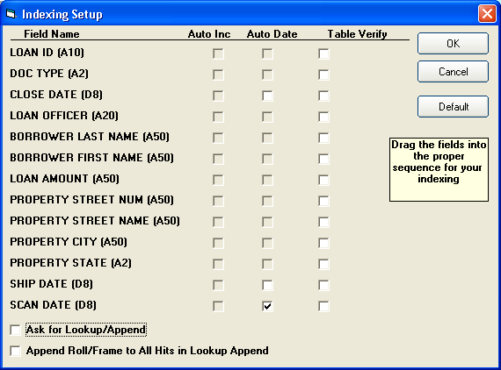

Page 8 support @versasoftware.com
VersaIMAGE Software Page 53

1.3.0 INDEXING SETUP OPTIONS continued…

Auto Inc - Automatically increments the number in the field. Available for numeric fields only.

Auto Date - Enters the current date automatically. Available for date fields only.

Table Verify - Allows you to set up a verification table for the field. Available for all field types. When checked, a Setup button is displayed to begin entering new table values, or to update existing table values.

Lookup/Append - Activated with the Ask for Lookup/Append checkbox. Check the box, if you have imported a database and wish to match keyed data on the first database field with the imported database. In case of a match the additional database fields will be filled in automatically.

Select entry options for whatever fields you want to apply them to:

- Only the options that are not grayed out are valid for a field.
- In cases where more than one option is, you can only select one.

To enter your index values in a different order, drag and drop the Field Name values into the desired entry order.

To remove all setup options, click the Default button. Your original order will be restored and all options you have set will be removed.

When you finish, click the OK button to save these settings.

10.0.0 HOW TO CREATE CD’s
Note: You might need to create a “Pre-mastering CD” folder on a local drive using Windows Explorer before starting this process.
Click Tools then select Build CD Image.
The CD Mastering / Pre-mastering window will display.
Select the path to the Pre-mastering CD folder and click OK.
The Build CD window will be displayed.
Specify a CD Volume ID name (up to 8 characters).
Select the VersaView PDF format for the CD
Select the image batches to be put on the CD
Click on the batch in the list on the left. To select consecutive batches, keep your left mouse button pressed and drag your pointer over the batches you want to select.
Click Add and the selected batches move to the list on the right.
To remove a batch, highlight the batch on the right, click Remove
When you have selected all the batches to copy, click OK.
A copy confirmation message will be displayed.
Click OK to begin copying the batches.
A progress meter will be displayed to show you how many records have been copied so far.

The Pre-mastering folder will have a directory structure with a .CSV file in the root directory, a subdirectory named the same as the CD Volume ID, and subdirectories in that directory for each of the batches selected. Use your local CD burning application to copy the Pre-mastering folder to the CD.

10.1.0 REGISTER A NEW CD FOR USE IN VERSAIMAGE-GOLD
Open the database where you want to rebuild the records.
Insert the CD containing the database records and images into your CD-ROM drive.
Select Register New CD from the Tools menu.
The Register CD window will be displayed.
Select your CD Drive from the CD Drive list box. The Volume ID for your CD will be displayed in the CD Volume ID field.
Click OK to build your database records from the CD.

NOTE: If you Register a CD that was created on the same Gold system, the CD information will be purged from Gold!

Page 52 Support : (810) 225-9720
VersaIMAGE Software Page 9

9.0.0 PDF PROCESSING OF IMAGES
This process converts the selected file or images to a file with a PDF format. This is useful for transferring files, creating PDF e-mail attachments, or just viewing the images with the Adobe Acrobat reader. The resulting file can also be written out to a CD using the Build-CD Image option.

To convert images
Search the database for the desired image(s). By default, all images within a selected folder will be converted and written out to a file. Specific images within a folder can be selected by holding down the CTRL key and then single right mouse click on the individual image thumbnails. When selected, the image number under the thumbnail will be highlighted. Release the CTRL key when all of the desired images have been selected, the selected thumbnails will remain highlighted.

Click Tools then the Convert Selected Image(s) to PDF option.
The Write Data Record to PDF confirmation is displayed.
Click Yes to continue.

The converted images are appended onto a title page, the PDF file is created, and the Adobe Acrobat reader is automatically started up to view this new file.

1.4.0 IMAGING OPTIONS
When you index paper documents or other non-film images, you have the following image storage options:

Single-page images with folder files
When you group the images into folder files, each group has an index record. You search for a document by searching for the record. All pages in the group will be displayed with the record.

Multi-page TIFF files
Multi-page TIFF images store the separate pages of a document in one file. There is a record for each file. You search the database on a record-by-record basis. All pages in the file will be displayed with the record.

Single-page images without folders
When you index single-page images individually, each image has a record. You search for the image on a record-by-record basis. Each image will be displayed with its associated record.

Note: With manual intervention, you can create folders in databases with single images to accommodate the occasional multi-page document.

To set the Imaging Options
Select Preferences from the File menu.
Select the Imaging Options option. The Imaging Options window will appear.

Page 10 support @versasoftware.com
VersaIMAGE Software Page 51

1.4.0 IMAGING OPTIONS continued…

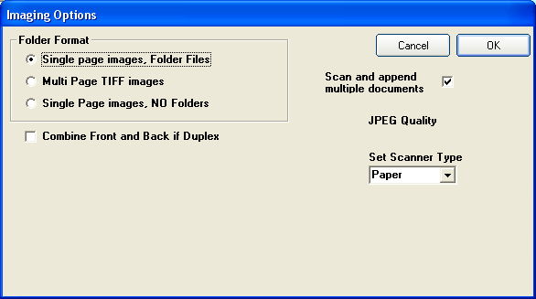

- Select the appropriate Folder Format
- For color quality the quality selector JPEG Quality (1-100) allows manual adjustment of scanned image quality. (60 is the default)
- If scanning checks in DUPLEX mode the front and backsides of a check may be placed on the same image by checking the Combine Front and Back Duplex box.

Click OK to save these settings.

IMAGE QC continued...

8.4.0 DELETE IMAGE(S) IN A FOLDER OR MULTI-TIFF FILE
Single-left click twice on the record to be modified in the table to view the associated images in thumbnail display mode. If you clicked too fast and are now viewing the record in Single-Record mode, that’s OK also. Images can be deleted while being displayed in thumbnail mode, but it is recommended that you first single-left click on the image(s) to enlarge the image display to confirm that the correct image(s) will be deleted. Right click on the enlarged image to return to thumbnail display mode.

To select image(s):
Single image - Right click on the image to highlight the page number
Multi-image - Right click on the first image, then press and hold down the Ctrl keyboard key and right click on the other image(s).
Image Block - Right click on the first image in the block, then press and hold down the Shift keyboard key and right click on the last image of the block.

Release the keyboard key, if needed.

Press the Delete key on the keyboard and then click Yes to confirm the delete request. NOTE: The Data record will not be deleted, only the selected image(s).

8.5.0 DELETE DATA RECORD WITH TIFF IMAGE AND FOLDER
Single-left click twice on the record to be deleted in the table to view the associated images in thumbnail display mode. If you clicked too fast and are now viewing the record in Single-Record mode, that’s OK also.
Press the Delete Record 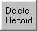 button on the toolbar.
On "You are about to delete a selected record" prompt click OK.

Page 50 Support : (810) 225-9720
VersaIMAGE Software Page 11

8.3.0 MAKING A GLOBAL CHANGE TO INDEX INFORMATION
In Image QC, select the first row of the data you want to change. To select several sequential rows, hold the Shift key down and click on the last row desired. The block of rows will be highlighted, release the Shift key.

After you select a row(s), the  button will be activated. Click Change All and the Change Records window will appear.

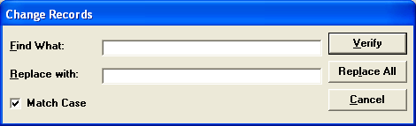

In the Find What text box, enter the text you want to change.
In the Replace with text box, enter the replacement text.
Check the Match Case check box to match case when it looks for the text (e.g., find only "Company" and not "company").

Press one of the following to start your search:
Verify - Confirm each change before it is made.
Replace All - Make replacements globally without confirmation.
Cancel - Cancels the operation and exits from the function.

If you select Verify, the program will stop on each change and ask you to confirm it. Click on one of the following:
Yes - Makes the change
No - Leaves it as is
Cancel - Cancels the operation and exits from the function. Pressing it will not affect any changes you have already made.

1.5.0 SPECIFY THE SEARCHING RESULTS SORT SEQUENCE

By default, searching results are displayed by the first three database fields, each in ascending order. However, if required, you can specify a custom searching results display sort sequence. To specify a new display sort order, click on File then Preferences and Sort Sequence.

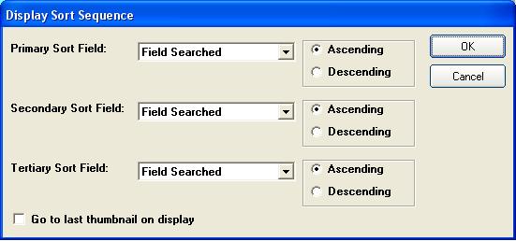

Click the Primary Sort Field drop-down arrow to reveal the database field names. Click on the desired field name, then select either Ascending or Descending display order. Repeat as needed for the Secondary and Tertiary sort fields.

When finished, click OK to save these settings.

Page 12 support @versasoftware.com
VersaIMAGE Software Page 49

PRINTER, EMAIL, & FAX SETUP

1.6.0 PRINTER SETUP
Click File then select the Setup Printer option. The Print Setup window will be displayed.
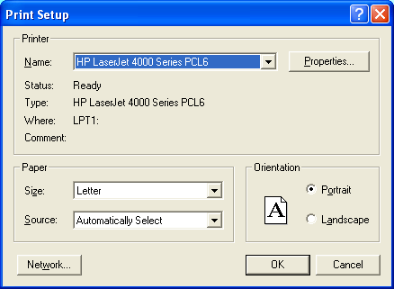
Select your default system printer from the Name drop-down list box. If your printer is not in the list, then it is not installed and recognized by Windows. The printer must be installed in Windows before it can be setup in the application. Contact your local System Administrator for assistance with locating or installing your default system printer. Click the OK button to specify this printer information to the application.
Note: If you do not have a fax modem, or if you do not want to use your fax modem with the application, you can use the "Fax" option to setup an alternate printer. In this case, your image would print on your primary printer when you select Print Image and on your alternate printer when you select Fax.

7.4.1 INDEX FROM PAPER
Click on Index then Index from Paper. Select Yes or No for Look-Up Append mode (See Section 7.2.0 for description) and proceed with data entry. Press Enter or click OK after each record has been entered.

8.0.0 HOW TO USE IMAGE QC AND MODIFY IMAGE FILES
Click on Index then Image QC and select the Batch number to process.

8.1.0 TO RESCAN AN IMAGE IN THE IMAGE QC MODE
Find the image to be rescanned and, single-left click on the image to enlarge the image display. Load the document into the scanner hopper and click the Rescan  button.
Right click on the new enlarged image to return to thumbnail display mode. Click OK for more Image QC processing, or click Exit QC.

8.2.0 MODIFY INDEX DATA IN RECORD
Single-left click on the record to be modified in the table and click the 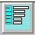 button to view the record in Single-Record mode. Tab to the appropriate field(s) and modify the index information for the record.
Click OK for more Image QC processing, or click Exit QC.

Page 48 Support : (810) 225-9720
VersaIMAGE Software Page 13

7.4.0 SPLIT BATCH-SCANNED IMAGES INTO IMAGE FOLDERS

This function allows the user to 'cut and paste' images from an existing folder into a new folder. During a batch scan process using Separator sheets to automatically split the images into folders, the separator sheets will be ignored if the Use VersaIMAGE Separator Sheets option was not selected on the Batch Scan window, if they were inserted upside down, or if the black patch area is not dark enough due to repeated copying. New original separator sheets can be printed from the default application directory, file name VersaSEP.doc. The sensitivity level for recognition of the black patch area on the separator sheet may be adjusted using the Separator Darkness control on the Select Batch/Roll window.

To split a folder that has embedded separator sheets
- Click on Index then Split Image Folders.
- Click Yes to the Display image count prompt.
- Click on (select) the correct batch number to be split.
- Click OK and watch the split occur in the Processing window.
To manually split images into a new folder
- Search the existing folder for the beginning image to be split out. When located, single right mouse click on the image to highlight or select it.
- Search the existing folder for the ending image to be split out. When located, press and hold down the Shift key and single left mouse click on the ending image to highlight or select it and all of the images in between. Release the Shift key.
- Press the F12 function key and select the Split Type.

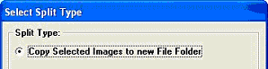

- Click the OK button and the images will be 'cut and pasted' into a new folder.

1.7.0 EMAIL SETUP
Click File then Preferences then select the Email Setup option. The Email Setup window will be displayed.

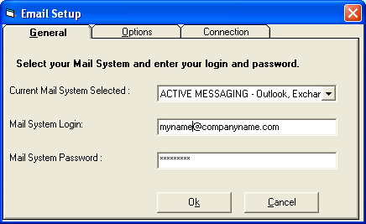

Select the Current Mail System from the values in the drop-down box. Then, specify your email address (Login) and password.
Click the Options tab and check the Use your default profile option.

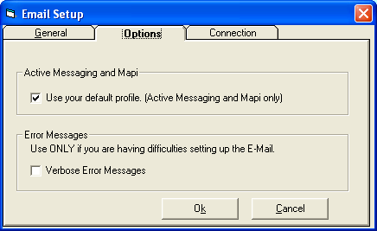

Page 14 support @versasoftware.com
VersaIMAGE Software Page 47

Then, click the Connection tab to specify how you will be connecting to the Internet.

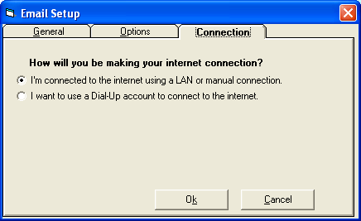

When finished, click Ok to save the setup information.

Click the OK button to complete the Auto-Indexing Zone definition.

A Start Processing? window will display.

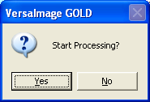

Click No to define additional Zones.

Click Yes to begin auto-indexing the records.

Auto-Indexing Zones are database specific and retained even when users exit and re-enter the VersaIMAGE-Gold application. Zones defined for one database will not carry over to another database. The zoning information for each database must be defined and will be remembered for each database.

7.3.1 CLEARING DEFINED ZONES
To clear the Zones for a database, press the button on the Zone Settings window.

Caution: Pressing the Clear All Zones button will immediately clear all of the defined Zones. There is no Clear All Zones confirmation opportunity, so when the button is pressed the Zones get cleared.

Page 46 Support : (810) 225-9720
VersaIMAGE Software Page 15

Specify the barcode format, if a single or multi barcode Zone Type was selected. Click the down-arrow to reveal the available options.

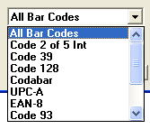
Note: Select the All Bar Codes option if you do not know the specific barcode format.

Again for barcodes, specify the action to be taken if the barcode is not recognized.

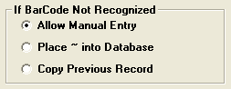

1.8.0 FAX SETUP

Click File then select the Setup Fax option. The Print Setup window will be displayed.

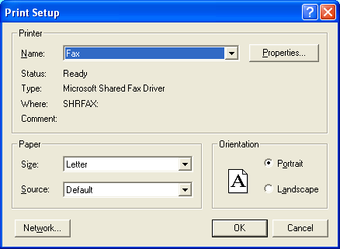
Select your fax modem from the Name drop-down list box. If your fax modem is not in the list, then it is not installed in Windows. The fax modem must be installed in Windows before it can be setup in the application. Contact your local System Administrator for assistance with installing your fax modem.
Click the OK button to specify this fax information to the application.

Page 16 support @versasoftware.com
VersaIMAGE Software Page 45

1.9.0 OCR PROCESSING SETUP
Processing required to create OCR text for images can take about 3 – 5 seconds per image and consume significant system resources. Thus, planning for when this processing occurs is important to reduce any impact to the scanning workflow. For flexibility, the OCR text processing can be specified to occur at scan time, delayed until the system sits idle for at least five minutes, or both.

To specify OCR processing at scan time, click Tools then OCR then click the Create OCR on Scan option.

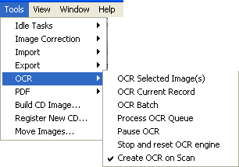

For delayed OCR processing, click Tools then Idle Tasks then click the Use Idle Tasks option.

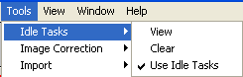

Or, for complete coverage, you can specify both options.
Notice the Zone Number is 1. When multiple Zones are defined, this field confirms the identification of the Zone being configured.

Next, specify the Field to Enter that will receive the information from this Zone. Click the down-arrow to reveal other index field names. Click on the appropriate field name to select.

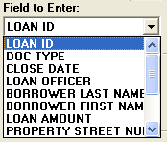

Note: Zone Number 1 is not required to be associated with the first index field name. Also, database index field names will vary, depending on the database currently open.

Next, specify the Zone Type. Click the down-arrow to reveal the available options.
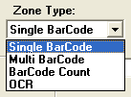

Page 44 Support : (810) 225-9720
VersaIMAGE Software Page 17

7.3.0 AUTO-INDEXING USING OCR AND BARCODE ZONES
This feature works best with documents that have index text and barcode information in consistent areas, such as with a form or an invoice.

Setting up an Auto-Indexing Zone

Click on Index then on Index Images.
Select (click on) the desired Batch number. Click OK.
The first image from the first record requiring indexing from the selected Batch will be displayed in enlarged mode.
Click the Zone  button.
The button will change to  and the cursor will change shape.
You are now ready to define the first zone.

Click and drag with left mouse button to form a box around the image data area which will be used for indexing purposes. Release the mouse button and the box will be labeled with a “1”, signifying that this is the first Zone defined, and a Zone Setting configuration window will be displayed.

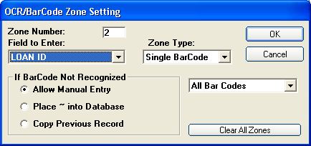

The OCR Status bar
Monitor the status and progress of the OCR process from the OCR Status bar. A red status light means the OCR process is not active. A yellow light means the OCR process is active, but paused. A green light means the OCR process is active and currently running.

1.9.1 OCR PROCESSING OPTIONS FOR EXISTING IMAGES
Several options also exist to create OCR text for existing images.

OCR Selected Image(s)
This option uses OCR processes on the currently selected image(s) and creates textual information.

OCR Current Record
This option uses OCR processes on the current record. This function only works when a single record is shown.

OCR Batch
This option uses OCR on a specific batch. Clicking on this function will open the select batch window, and after selecting the batch the processing will begin.

Process OCR Queue
Scanned images are placed into a queue for OCR processing once the scanning process ends. The queue will usually be processed automatically however it may be started by the user with this command.

Pause OCR
This option allows you to pause the OCR process so that the CPU may dedicate most of its work on current applications and functions, if OCR is not needed until later.

Stop and Reset OCR Engine
This option clears the OCR Queue and stops the engine.

Page 18 support @versasoftware.com
VersaIMAGE Software Page 43

1.10.0 IMAGE DISPLAY MODES
There are two search results display modes for viewing scanned images; Table mode or Single Record Mode.

Click on the Search button on the bottom of the display screen.
Click YES to the Search Entire Database window.
The search results (Hits) are found and displayed in a table display format.

Click once (highlight) the 3rd Line, Loan ID 252758
Click once on this line again and the images for this record are displayed on the right side of the screen. You can scroll up and down the table and view other images by pressing the up-arrow or down-arrow keyboard keys.

When finished, click the Clear button to close the Search Hits list.

Note: If you double-click on a Hit line, the images will be displayed in Single Record mode. You can also toggle display modes by clicking on the toolbar icons: 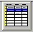 for Table mode, and for Single Record mode.

1.11.0 VIEWING SCANNED IMAGES
Click on the Search button on the bottom of the display screen.
Click YES to the Search Entire Database window.
Double-click on the 4th Line, Loan ID 252333
Thirteen images are now visible in THUMBNAIL display.
Click once on the Page 3 image to enlarge the image.
Now, double-click on the enlarged image to view it full-screen.
Double-click on the image again to reduce back to enlarged display.

Right-click on the image at any time to reduce back to thumbnails.

7.0.0 INDEXING FUNCTIONS

7.1.0 INDEX FROM IMAGE
Note: Scanned images must be available for indexing purposes.
Click on Index then on Index Images.
Select (click on) the desired Batch number, then click OK.

The Look-up Append mode window will display.

- Answer Yes if you are matching images to data which has previously been imported into the Database. Now key-in data from the image into the first indexing Field on the screen (Note: Use Indexing Setup feature to move the matching index field to the first data position). After the first index field is keyed VersaIMAGE-Gold will automatically match this field with the imported data and fill in the other data fields from that data.

- Answer No if you have not imported data. Key the index data manually into the indexing fields.

7.2.0 ZOOM ZONES FEATURE
This feature works best with documents that have index information in consistent areas, such as with a form or an invoice.

Click and drag with left mouse button over the image area (i.e. Address Field) which must be keyed for indexing purposes. Let go of Mouse button. A Zoom Zone area has been created. Now key-in data from the image zoom zone into the appropriate index field. Repeat for each field. VersaIMAGE-Gold remembers each Zoom Zone selected for each field! On subsequent images, the areas required for each data entry field during indexing will automatically zoom-in.

Page 42 Support : (810) 225-9720
VersaIMAGE Software Page 19

6.2.1 CREATE AN EXPORT TEMPLATE
Select all the fields you want to export but do not start the export.
Click the Save Template button.

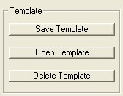

The Save Export Template window will appear.
By default, the template will be given the same name as your database:

If you want, change the file name in the File Name field.
Do not change the extension! The template must have the extension .TPX to be recognized as an export template.

Click Save to save the template.

Hint: If you will be exporting from this database periodically and will generally use the same template, save it with the same name as the database (the default name). Then it will always be opened for you when you export.

The dividing bar in the center of the screen can be moved left or right to allow more, or fewer, images to be displayed per screen. To adjust the bar, move the cursor over the bar until the cursor changes shape. Then, hold down the left mouse button and drag the bar to the left or right. Release the mouse and the bar will remain in the new position.

OTHER IMAGE VIEWING FEATURES

1.11.1 IMAGE ROTATION
Left-click again on an image to display it enlarged.
Now click the Rotate  button once in the upper-right corner.
The image will rotate 90 degrees clockwise.
Click 3 more times to rotate image back to original display.
Right-click on the image to reduce it back to a thumbnail display.

1.11.2 IMAGE DE-SKEW
Left-click on an image you wish to de-skew, the image will enlarge.
Click the Deskew  button, to the left of the Rotate button.
The image will display straighten out in a new window.

1.11.3 CHANGE DATA IN INDEX FIELDS
Click the Change button located on the bottom of the display screen. The index value of the first data field is highlighted.
Press the Tab key on keyboard once to get to the Doc Type field. Type in a new Doc Type value (any two digit value).
Click the OK button on the bottom of the screen.

Note: This function is controlled by Security Levels. If you do not want a user to have access to this function please ENABLE passwords. See Section 12.1.0 for Security setup.

Click on Clear button at the bottom to close this record and save the index information change.

Page 20 support @versasoftware.com
VersaIMAGE Software Page 41

1.11.4 CUSTOM AREA ZOOM
Click on an image with left mouse button to enlarge the image.
Move the mouse to an area within the image to be zoomed in on.
Click, hold, and drag the left mouse button over the enlargement area. Let go of the mouse button and the Zoom is visible.
Use the Scroll Bars at the bottom and right side of the image to "pan" the image, if needed.
Right-click on the image to return the image to full-page display.
Right-click on the image again to return the image to thumbnail display.

2.0.0 PERFORM DATA SEARCHES

There are two ways to search for images and information within a database; searching the Index fields, and searching the OCR Image text. Remember, VersaIMAGE-Gold automatically converts text (not handwriting) on each scanned image into searchable text.

INDEX DATABASE TEXT SEARCHES

A. TEXT SEARCHES: (Fields: Alphanumeric)
2.1.0 Exact Text

Locate the "Text Search Methods" box at the top of the screen.
Click on the down-arrow and select the Exact Text option.
Press the Tab key to move the cursor to the Loan Officer field. Type Neil Peterson into this field and click the Search button. The Search found the “Neil Peterson” loan, because of an exact match on the field value. This search type is case-sensitive.

Click the Clear button to clear the search results.

After selecting the fields you want to export, or opening the template that contains your field definitions, then select your export options:

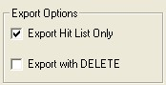

Note: These options are grayed out and not available unless a Search Hit List has been selected to be exported.
Check Export Hit List Only if you only want to export the records in your hit list. Warning: If you do not check Export Hit List Only, your entire database will be exported, even if you created a hit list first.

Check Export with Delete if you want the records you export deleted from your database.

Click the Start Export button to start the export.

If the file you are exporting to already exists, you will be asked if you want to append the records to the end of the existing file.
To add the exported records to the file, click Yes.
To overwrite the exiting file, click No.

During the export, you will see a progress bar will display on the screen. When the export is finished, a completion message will appear.

Page 40 Support : (810) 225-9720
VersaIMAGE Software Page 21

When you define your export record, select your fields in the order you want them placed in the export record. If you need to insert extra space or characters in your record at certain points to conform to record structure requirements, you can insert a fixed field of a specific length and fill it with a character string. If you plan on exporting from this database more than once, you can create an export template for your file definition (see Section 6.2.0).

To select fields to export
On the left side of the screen, click the number of the field you want to export. Click the Copy to Record button.
For ASCII files:
A window for entering the field length will appear. The field length defined for the database will appear as a default:
If the field is a numeric or date field, the dialog will contain a Length field and a Format field.
For other fields, the window will only contain the Length field. Change the field length if necessary. If you enter a length that is shorter than your database field, your data will be truncated.
If the field is a numeric or date field, select the Format type.
Click OK. The data for that field from the first record in your file will be added to the current end of the export record. The record length will be incremented accordingly.

To add a fixed field (for ASCII files only)
Click the Add Fixed Field button. The Fixed Field Definition window will appear.
Enter the number of characters you are adding in the Field Length field.
Enter the character string in the Field Contents field. For spaces only, leave it blank.
Click OK. The fixed field will be added to the current end of the export record. The record length will be incremented accordingly.

Note: The next field you choose to export will be added immediately after your fixed field.

2.2.0 Text Starts With

Locate the "Text Search Methods" box at the top of the screen.
Click on the down-arrow and select the Text Starts With option.
Press the Tab key to move the cursor to the Loan Officer field. Type “Neil” into this field and click the Search button. This search type is not case-sensitive.

Click the Clear button to clear the search results.

2.3.0 Text Contains

Locate the "Text Search Methods" box at the top of the screen.
Click on the down-arrow and select the Text Contains option.
Press the Tab key to move the cursor to the Loan Officer field. Type “Peter” into this field and click the Search button. The Search found the Neil Peterson loan with 255 images up. This search type is not case-sensitive. Click the Clear button to clear the search results.

B. NUMERIC RANGE SEARCHES: (Fields: Numeric, Date)
2.4.0 Exact searches are made if only the first field is used. If the
second field is used (to the right of the first field) RANGE searches are conducted. (i.e. Enter 11/22/2004 and 1/12/2005 in “Close Date” field respectively. Click Search to find all loans with close dates equal to or between these values)

2.5.0 If more than one hit has been found:
Use the Up and Down arrow keys to scroll the list.

Click the Clear button to clear the search results.

Page 22 support @versasoftware.com
VersaIMAGE Software Page 39

OCR IMAGE TEXT SEARCHES

The OCR Image text searches use a different type of method called Fuzzy Logic to find information. This provides the benefits of a powerful search engine, with the flexibility of allowing ‘close’ matches to the search criteria by adjusting the Fuzzy Accuracy percentage. A higher percentage will produce more accurate and more exact results to the search criteria, while a lower percentage will find more ‘close’ matches. Also, at least one Index search value must accompany an OCR Search value. Customarily a database Search is made first on a main search field, and then an OCR Field Search is made to find a specific aspect of the first search field.

2.6.0 SETTING THE FUZZY ACCURACY PERCENTGE
Locate the Fuzzy Accuracy Percentage button on the bottom status bar. The current percentage value is displayed on the face of the button. Click on this button and the Fuzzy Settings window is displayed. To adjust the setting, left-click and hold on the slide arrow 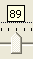 and drag it to the left or right. The percentage value is displayed above the arrow. For current demo purposes, slide the arrow completely to the right for 100%.
Click OK to save the current percentage value.

2.7.0 PERFORM OCR BOOKMARK TEXT SEARCHES

Let’s try to find something based on the OCR. From the search screen, enter “Neil Peterson” in the Loan Officer field. Then in the OCR Search field choose the “Brautiful Subdivision” OCR bookmark. There should be one hit, but it is not the document that you are looking for. Click on the Fuzzy button on the bottom and drag the percentage to 79. You now have 14 hits.

6.2.0 EXPORTING TO A FLAT ASCII FILE OR A COMMA SEPARATED FILE
To export to a flat ASCII file, you must open the database you want to export from and specify a destination file for your exported data. You may optionally narrow down your records to a specific hit list.
If you do not want to export your entire database, select your records as follows:
Enter the search criteria that will find the records you want.
Click Search.
Verify that the search yielded the result you wanted.
Select Tools, then Export, then click on the Flat ASCII File or Comma Separated File option.
The Save As window is displayed. Verify, or select, the correct folder name where you want to save the exported file is displayed in the Save In field.
Enter the destination file name:
If you are creating a new file, enter the file name in the File Name field. Select a Save as type with .TXT (TEXT) extension for ASCII or a .CSV extension for Comma Separated Files.
If you are replacing an existing file or appending records to an existing file, click on the file name to select it. Its name should appear in the File Name field.

Reminder: If the file you are replacing or appending to does not have the appropriate extension, select All files from the Files of type list so all files will appear in the list.

Click Save and the Export to ASCII File or the Export to Comma Separated File window will appear.

The left side of the screen contains the fields in the record and data from the first record in the database. The right side contains your export options and a field for your export record. You do not have to export all fields in the database record, only the ones you need. You can also specify the order in which you want the fields exported. This allows you to tailor your data to specific applications.

Page 38 Support : (810) 225-9720
VersaIMAGE Software Page 23

To export the contents of a distribution folder as a multi-image TIFF
Right-click on the distribution folder to be exported, to display the folder menu. Then, click on Export the Folder. The Save Folder as Multi TIFF window will appear.

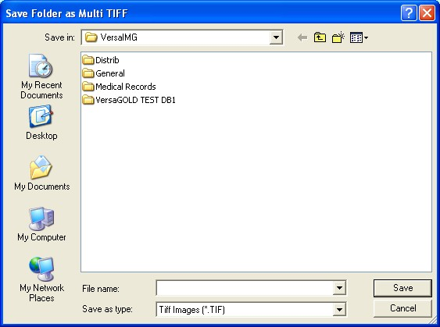

In the Save in field, navigate to the directory where you want to save your folder. Then, type the file name you want to save the image under in the File name field and click Save.

When the file creation process completes, the new file contents will be displayed in a viewer for your review. Close the export file and return to the Gold application.

2.8.0 VIEWING THE OCR IMAGE TEXT
On the first image, OCR hit 7, click on view OCR, or click the middle mouse button, and notice that the word “beautiful” is highlighted. Because the fuzzy was set to a lower percentage, it was able to find it even though the word was misspelled. The drop down menu that you used to select “brautiful subdivision” contains many other OCR Bookmarks. For a complete list of all the OCR Bookmarks in this demo see page 9 in the Neil Peterson record, which is also OCR hit 9 on the current screen. These bookmarks are preset to go with this demo, but new bookmarks can be configured to suit your needs. This can be done by clicking File, then Preferences, and then selecting OCR Bookmark Setup. From this menu you can give your bookmarks titles, specify the default fuzzy search percentage, and specify the words or phrases that you want to search for using Boolean operators(AND, OR, etc.)

2.9.0 EXTRACTING OCR IMAGE TEXT
With the cursor on the OCR Image text, again click the center mouse button once. If you have a text editor, two options for extracting the OCR text are displayed; otherwise, only one is displayed.
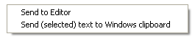
To send text to the Windows Clipboard, first highlight the desired text, then click the center mouse button to display the options, and click on the Send (selected) text to Windows clipboard option.

Click the Clear button to clear the search results.

Page 24 support @versasoftware.com
VersaIMAGE Software Page 37

3.0.0 PRINT & FAX IMAGES AND FOLDERS

3.1.0 PRINT OR FAX FOLDER IMAGES IN THUMBNAIL DISPLAY
Click on the Search button on the bottom of the display screen.
Click YES to the Search Entire Database dialog box.
Double-click on the 4th hit line, Loan ID 252333.
Multiple images are displayed in thumbnail format with a maximum of 16-pages up on the monitor screen. If you print or fax images in thumbnail format they will be in a maximum of 9 images per page format. This way, the images are still eye readable on paper. Thus, one may quickly fax an entire folder to the user. The user selects a particular image, circles it and faxes it back for retransmission in full size format.
Review the printer settings by clicking on File then Setup Printer. Verify, or click on, Portrait paper orientation, then click OK.
With the images displayed as thumbnails,
- To print: click on File then Print Image, or click on the  toolbar icon.
- To fax: click on the  toolbar icon.

Click YES to the question "Print as Thumbnails" or "Fax as Thumbnails". Your local printer or fax software will now print or fax the images.

3.2.0 PRINT OR FAX ALL IMAGES IN A FOLDER
With images in thumbnail display, click on the PRINT or FAX icon in toolbar (shown above). Click NO to the question "(Print or) Fax as Thumbnails". Your own PRINTER or FAX software will now print or fax all images full size.

3.3.0 PRINT OR FAX INDIVIDUAL IMAGES
Image must be in single image display, or enlarged, on the right side of the screen. If in thumbnail display, single-left click on the image to enlarge it. Click on the PRINT or FAX icon. Your own PRINTER or FAX software will now print or fax the image.

Click the Clear button to clear the search results.

Distributing the contents of a distribution folder
You can output the contents of a distribution folder to a printer, fax modem, or E-mail attachment. You can also export the documents to a multi-image TIFF file.

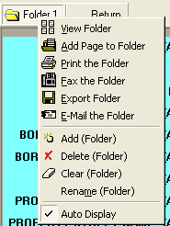

To print the contents of a distribution folder
Right-click on the distribution folder to be printed, to display the folder menu. Then, click on Print the Folder. The contents of the folder will be sent to your printer.

To fax the contents of a distribution folder
Right-click on the distribution folder to be faxed, to display the folder menu. Then, click on Fax the Folder. You will be placed in your fax application so you can complete the transaction.

To E-mail the contents of a distribution folder
Right-click on the distribution folder to be emailed, to display the folder menu. Then, click on E-mail the Folder. You will be placed in your E-mail application, with the folder contents attached as a multi-image TIFF file to a new email, so you can complete the transaction.

Page 36 Support : (810) 225-9720
VersaIMAGE Software Page 25

To add pages to the distribution folder
Find the record that contains the document(s) you want. Select the document(s) by:

• To select one page, either click your left mouse button on the page or click your right mouse button on the page number.
• To select several non-sequential pages, hold Ctrl down and click your right mouse button on the page number label of the pages you want to select.
• To select consecutive pages, click your right mouse button on the page number label below the first document you want to select. Then hold Shift down and click your right mouse button on the page number label of the last page.

Place your mouse pointer on the distribution folder and right-click on it to display the folder menu.

Click on Add Page to Folder. The selected page(s) will be added and the current contents of the folder displayed.

Click Clear at the bottom of the screen to close the folder.

4.0.0 HOW TO SCAN PAPER IMAGES

4.1.0 SPECIFY A NEW BATCH NUMBER
Specify a new Batch Number for the images being scanned.
Click Scan then New Batch.
Specify Batch Number 100, then click OK.

4.2.0 USING IMAGE CORRECTION WHILE SCANNING
Image correction can be automatically applied to documents as they are scanned. Click Tools then Image Correction then Correction Options to review the settings. Or, click the Setup Correction button on the Batch Scan (F5) window.

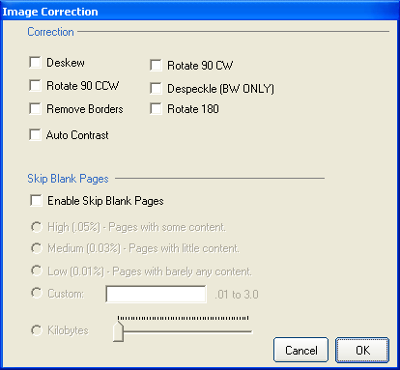

The check boxes toggle the associated option on and off; on or enabled when the box is checked, and off or disabled when the box is not checked.

Page 26 support @versasoftware.com
VersaIMAGE Software Page 35

- Deskew will straighten an image horizontally
- Rotate 90 CW will rotate the image 90 degrees clock-wise from current reference
- Rotate 90 CCW will rotate the image 90 degrees counter clock-wise from current reference
- Despeckle will remove random spots from the images
- Remove Borders will remove unwanted lines from around the edges of the images
- Rotate 180 will rotate the image 180 degrees from current reference
- Skip Blank Pages automatically eliminates pages determined to be 'blank'. Set the percent of whiteness threshold which will used to determine if a page will be considered blank, or not. Pages can also be skipped by size in Kilobytes
Click OK to save these settings.

To apply these image correction settings during scanning, click Scan then Use Image Correction. Or, click the Use Image Correction option on the Batch Scan (F5) window.

4.2.1 IMAGE CORRECTION OPTIONS FOR EXISTING IMAGES
Image correction can also be applied to existing images.

- Correct Image becomes a selectable option once an image is selected (highlighted). When clicked, this option will apply the image correction settings, specified above, to the current image.
- Correct All Images in Folder will apply the image correction settings, specified above, to the current opened folder.
- Correct Batch will open the Select Batch window so the user can select the appropriate batch number to process. After a batch number has been specified, the current image correction settings, specified above, will be applied to all of the images within the batch. Please note, this could take a large amount of time, depending on the amount of images being processed.

6.0.0 EXPORTING INFORMATION

6.1.0 DISTRIBUTION FOLDERS

Distribution folders are located at the top left of your screen. Place documents in this folder for printing, emailing, faxing, or export. By default, there is one folder called Folder 1. You may rename this folder and add additional folders. The distribution folders allow you to search your database and collect documents prior to distribution. They are not attached to a specific database, so you can pull documents from any number of databases for distribution at the same time.

To view a folder
Do one of the following to open a distribution folder:
• Double-click on the folder.
• Click your right mouse button to display the folder menu and select View Folder.

The contents of the folder will be displayed in the image area on the right of the screen.

To close the folder, click Clear at the bottom of the screen.

Note: If you are in the middle of a search when you open a distribution folder, you will be exited from that search when the distribution folder is displayed.

Page 34 Support : (810) 225-9720
VersaIMAGE Software Page 27

5.2.0 IMPORT TIFF IMAGES AND SPLIT INTO FOLDERS
Open the Database which will require the import of images.
From Tools menu, click on Import, then Import Images.

Click on the Auto Folders (based on image name) option.
Read the instructions in the yellow box display.
Specify the number of Folder Digits and Page Digits that will make up the generated Folder name. The default setting is 4 Folder Digits and 4 Page Digits. The total number will always add to 8 digits for the Folder name.

Click  to browse for the directory containing the images.
The Path and the TIFF image file names are displayed. By default, all of the images in the directory are selected (highlighted) for import. To select specific individual images, press Toggle All to de-select (un-highlight) all files, then click on (highlight) the specific images desired.

Click on Start Import.

Enter a Batch number from 1 – 99999 for the file(s) to be imported into. The number is automatically appended to the letters BCH to complete the Batch Number (i.e. 43 becomes BCH00043).

An import confirmation message is displayed.

Click OK and the import process begins.

4.3.0 MAKE FOLDER AND SCAN MULTIPLE IMAGES
This option can be utilized to quickly scan paper documents into a File folder (i.e. Legal, Personnel or Medical files...).

Place documents to be scanned into the scanner feeder.
Click on Scan then Index Folder and Scan, or press the F2 key.
The first image is scanned and Gold automatically switches to the Indexing mode. Key the index information (Folder name) into the index field(s). (Use Zoom Zones to better see key entry data in subsequent folder records! See Section 7.2.3 for details).

File the first image, and scan the remaining documents, by either:
1. Pressing the F5 key or
2. Click on OK.

Click the Exit button to complete the scan and to view the image thumbnails.

Click Search then Clear to clear the display of the image thumbnails.

4.4.0 SCAN BATCH TARGETS FOR FOLDER SEPARATION
VersaIMAGE Separator Sheets can be printed from Microsoft Word.
Open the VSC_Sep.doc file, located in the C:\VersaIMG folder. These Separator Sheets will allow automatic folder separation during a Batch Scan process when the Versa Separator option is selected from the drop down menu under Auto Document Separation. The images of these separator targets will be deleted automatically during Batch scanning by clicking on the Delete Separator Sheets option on the Batch Scan window.

NOTE: Always use original laser printed Separator Sheets.

INSERTING IMAGES INTO EXISTING RECORDS
Images can be inserted in existing records using the F3 key. First search for the record, then select the image you want to insert after, and then press the F3 key. All documents in the scanner’s hopper will be inserted.

Page 28 support @versasoftware.com
VersaIMAGE Software Page 33

4.5.0 SCAN A PAPER BATCH

4.5.1 BATCH SCAN SETUP OPTIONS
Place documents to be scanned into the scanner feeder, then press F5 or click Scan then Scan Batch. The Batch Scan window will appear.

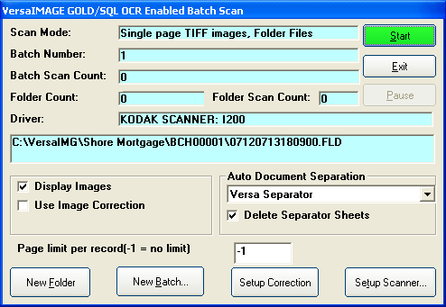

The scan mode and the number of the last batch scanned will be displayed in the box. The first time you scan a batch for a database and whenever you want to start a new batch, you will need to enter the batch number. To start a new batch:
Click the New Batch button
The New Batch Number window is displayed.
Enter a batch number between 1 and 99999 and click OK.
Note: The application will create a subdirectory folder for each batch scanned. The name will be BCHnnnnn where nnnnn is the batch number.

5.0.0 HOW TO IMPORT ASCII OR COMMA SEPARATED
FORMATTED FILES FOR "LOOK-UP APPEND" MODE

From Tools menu, click on Import, then Flat ASCII File or Comma Separated File. Select (click on) File with .TXT (TEXT) extension for ASCII or a .CSV extension for Comma Separated Files. Click Open. Notice the to be imported Data record in the top right section of the display.

The entire record may now be viewed by moving the slide bar from left to right. The total record length (character count) for the (to be) imported record is displayed below the import window.

Select (click on) the Field Number box on the left side to designate which field you wish the data to move into. With the mouse, click and highlight a Data field in the data record (right side) and click on Copy to Field. Repeat with all fields you wish to import.
Note: If you expect to import more data in the same format in the future, click on Save Template.

Click on the Start Import button on top center of screen to start import of ASCII or Comma Separated Data. This Data may be used with the Indexing / Look-Up Append mode!

5.1.0 IMPORT SINGLE PAGE TIFF IMAGES
Open the Database which will require the import of images.
Click on Tools then Import then Import Images
Disable “Auto Folders” feature (if it is checked "on").
Click to browse for the directory containing the images.
The Path and the TIFF image file names are displayed. Click on individual file names to select, or press the Toggle All button to select all files. Click on Start Import. Enter a Batch number from 1 – 99999 for the file(s) to be imported into. The number is automatically appended to the letters BCH to complete the Batch Number (i.e. 43 becomes BCH00043). An import confirmation message is displayed. Click OK and the import process begins.

Page 32 Support : (810) 225-9720
VersaIMAGE Software Page 29

4.6.0 SCANNING IN BATCH MODE

With the Scan Batch window still displayed, click Start.

The scanner will start scanning automatically. The page number and number of pages and folders scanned will increment each time a page is scanned, and the next file name will be displayed.

To interrupt scanning operations temporarily, do the following:
To stop, click Pause.
To continue, click Resume.

To make adjustments to the scanner, do the following:
Stop the scan with Pause.
Click Setup Scanner to access the scanner settings window.
Exit from the scanner setup and return to the Batch Scan window.
Click Resume to continue.

When the scanner is empty, the Start button will change to Resume and the Pause button will be disabled:
To continue with the same batch, load more documents into the scanner and click Resume.
To start a new batch, click New Batch and enter a new batch number. We recommend that you start a new batch every 5000 pages or when the software prompts you to do so.

Click Exit to complete the scan and to view the image thumbnails.

Click Clear to clear the display of the image thumbnails.

Select your Auto Document Separation option:
None - If you are not using separator sheets.
Versa Separator – If you are.

Important: You must select the use separator sheets option to create folder files or multi-image TIFFs automatically. If you select None, you will have to split the folders yourself even if separator sheets are inserted.

Check Delete Separator Sheets to delete the separator sheets as it creates new folders. This option will only be enabled if you selected the use separator sheets option.

Check Display Images to display the images as they are scanned (recommended).

To apply background image correction, do the following:
Check the Use Image Correction option. If it is already checked, background image correction is currently enabled for your system.
Click Setup Correction to display the Image Correction window and select your correction options.

Caution: When you enable or disable Use Image Correction from this dialog, it is enabled or disabled on the Scan menu. This setting and whatever options you select will be in effect for all scanning that is done from this point on until you disable it. It does not apply to this batch or this dialog only.

4.5.2 DUPLEX SCANNING
To scan in Duplex mode, or both sides of the document, click the Setup Scanner button and set the scan mode to duplex there.

Page 30 support @versasoftware.com
VersaIMAGE Software Page 31

